Camp William Penn Site Lesson

By Amy Cohen, Education Director, History Making Productions and author of O.V. Catto: The Forgotten Hero

7322 Sycamore Ave; La Mott
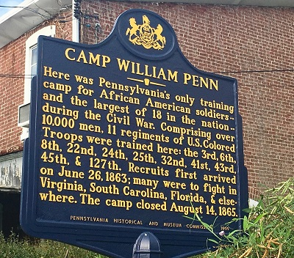
In June of 1863, a call went out for volunteers to serve in the Union Army because Confederate forces were moving toward Pennsylvania. Though Congress had authorized the enlistment of black soldiers in July of 1862, it took the Emancipation Proclamation and mounting Northern losses to initiate the recruitment and training of black soldiers. With the consent of his principal, Ebenezer Bassett, Octavius Catto eagerly joined the campaign to gather black troops and assembled ninety volunteers, including many of his Institute for Colored Youth students. Catto and the other volunteers traveled to Harrisburg by train to offer their services to U.S. Army. The commanding officer in charge, however, rejected the group and sent them back to Philadelphia. The stated reason was that they were not enlisting for the required time period.
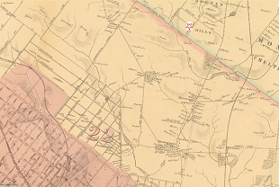
1862 Map with location of Camp William Penn indicated
from Atlas of Philadelphia, Samuel L. Smedley.
J. B. Lippincott & Co. (1862).
In spite of this, Catto and others again took on the mission of recruiting black soldiers when later that month orders were given to form ten companies of colored troops, each to be made up of eighty men. To fulfill this order, Camp William Penn was quickly established just north of the Philadelphia border in Cheltenham Township. Located on land owned by anti-slavery crusader Lucretia Mott's son-in-law, the Camp officially opened on July 4th, 1863. Nearly 11, 000 men were eventually trained at Camp William Penn, the first training camp ever set up specifically for black troops. Many of the enlistees had recently fled slavery.
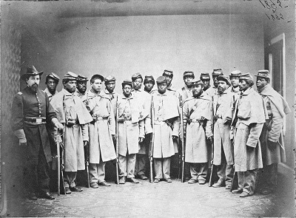
This photograph was taken in Philadelphia, probably in 1864. It was used to create recruitment posters for the USCT, as detailed in Negro History, 1553-1903: An Exhibition of Books, Prints, and Manuscripts from the Shelves of the Library Company of Philadelphia and the Historical Society of Pennsylvania (Philadelphia 1969). The image was scanned and uploaded by the University of Virginia in 2007 as part of an analysis of the misuse, misattributuion and photographic doctoring of this photograph to create falsified historical evidence.

Major Louis Wagner, a Union officer injured at the Battle of Bull Run was the commander of Camp William Penn. Like Wagner, all of the officers in charge of United States Colored Troops (USCT) at Camp William Penn were white. In spite of serving their country, black soldiers often received harsh treatment both at the Camp and on visits to Philadelphia. Indeed, the first regiment trained at Camp William Penn was not permitted to parade through the city for fear of violence against the troops.
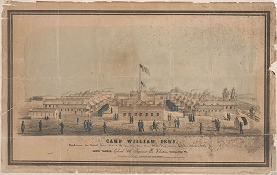
Camp William Penn
Louis N. Rosenthal, 1864
The original lithograph of this image is in the collection of the Free Library of Philadelphia and has a pencil-written note on the reverse: "by Max Rosenthal"
Max was the brother of Louis, the publisher, and probably did the actual drawing of the camp
Many whites living in the area surrounding the camp were Quakers with abolitionist tendencies and welcomed having a training ground for black soldiers in their midst. Lucretia Mott was a frequent visitor, sometimes bringing baked goods and other times sharing religious exhortations.
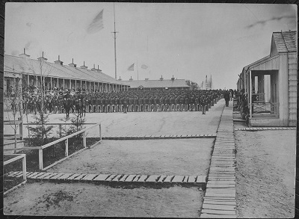
26th United States Colored Volunteer Infantry
at Camp William Penn, ca. 1897
Public Domain Image from the National Archives and Records Administration
Although there is no record of Octavius Catto visiting Camp William Penn, notable African American leaders like Frederick Douglas and William Still did make the trip. Catto did have a strong personal relationship with Louis Wagner and would later serve under his command in the Pennsylvania National Guard. It is highly likely that through this relationship and others that Catto was connected to camp life and the men. Many friends and family members of the recruits, however, were unable to visit Camp William Penn because trains and streetcars did not allow black riders. The absurdity of this situation was one of the most compelling arguments for desegregating Philadelphia streetcars, a campaign for which Catto became a leader.
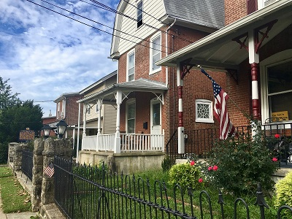
Enlarge this photograph to see how the military tradition lives on in La Mott
Camp William Penn closed on August 31, 1864. By that time, black regiments had proved definitively that black soldiers, though paid less and treated severely, could be as courageous as their white counterparts. Sadly, sixty percent of the Camp William Penn-trained 6th Regiment perished at the Battle of New Market Heights in Virginia. Two of the survivors were awarded the Congressional Medal of Honor for their bravery under fire.
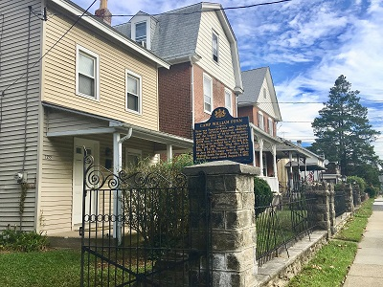

Though he had not served in the military like his two brothers, Octavius Catto received the honor of accepting a regimental flag on behalf of the Twenty-fourth USCT. He then gave a speech to a crowd of thousands of Philadelphians, both black and white, on April 15th, 1865-shortly after the Civil War had finally ended.

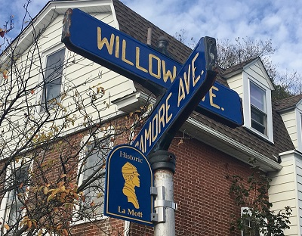
Street signs in La Mott depict the area's history as the home of Camp William Penn

During the era of Camp William Penn, the area now known as LaMott was mostly farmland. Today it is an overwhelmingly African American neighborhood within Cheltenham Township, an inner-ring suburb of Philadelphia. There is almost nothing left of the sprawling camp other than historical markers and the emblem of a USCT soldier on neighboring street signs.

Camp William Penn: Primary Source Questions
- Examine the photograph and the poster depicting United States Colored Troops with their commander, Colonel Louis Wagner (far left). What are similarities and differences between these two images? Why might the artist who designed the poster have made changes beyond merely adding color and a background? Compare images.

- Read the excerpt from a booklet published by the Supervisor Committee for Recruiting Colored Regiments and answer the following questions:

  - According the first two paragraphs, what were two reasons for the "urgent need of officers" to command colored troops?
  - The third paragraph explains a solution to the problem described in the first two paragraphs. Describe this solution and indicate the groups that were in charge of the effort.
  - As explained in the fourth paragraph, what purpose was Camp William Penn expected to play by the organizers of the Free School for Military Tactics? How might contemporaries of Octavius Catto, particularly those who had graduated from the Institute for Colored Youth such as Martine White have felt about the requirement that only white officers could lead black troops?

- Examine these two excerpts from an 1862 Philadelphia Atlas.
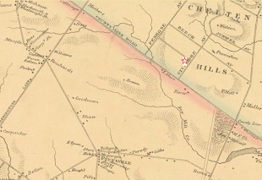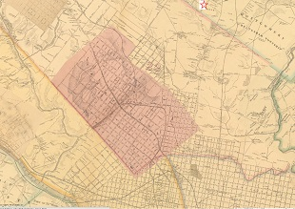

  - How can you figure out which areas were urban (city) and which were rural (countryside) using these maps? Which map is more helpful in making this determination?
  - Why might Camp William Penn have been located where it was? What would have been advantages and disadvantages of this location?

