Freedom Now Rally
Dedicated: Saturday, June 19, 2010
County: Philadelphia
Marker Type: Roadside
Categories: African American, Civil Rights, Government & Politics 20th Century
GPS Coordinates: LNG: -75.20232, LAT: 39.96296
Location: intersection of 40th St., Lancaster Ave., and Haverford Ave., Philadelphia
Marker Text: On August 3, 1965, Dr. Martin Luther King addressed a crowd of 10,000 at this intersection. His “Freedom Now” tour to Philadelphia, Chicago, Cleveland, and Boston was in gratitude for support given to his Southern Christian Leadership Conference. King brought his message into northern Black neighborhoods, supporting local civil rights efforts and raising funds. His goal was to empower the formation of a coalition to address their common concerns.

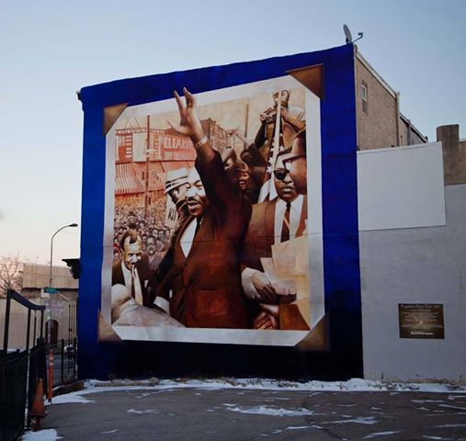

This mural of King at 40th Street and Lancaster Avenue helps mark the site of the historic speech.
Despite the problems facing blacks -- in Philadelphia, and around the nation -- in 1965, there was something of an air of a victory tour for King's "Freedom Now" rallies, which hit a number of Northern cities during what became the long. hot summer of that year. In less than a year's time before King rallied in Mantua, the civil rights leader had won the Nobel Peace Prize and led the legendary Selma-to-Montgomery march; in just a few days (Aug. 6, 1965), he would stand next to then-President Lyndon Johnson as he signed the Voting Rights Act, the second major piece of civil rights legislation in just two years. Two years later, MLK returned to Philadelphia for his last “Freedom Tour”. Months later, he was assassinated on
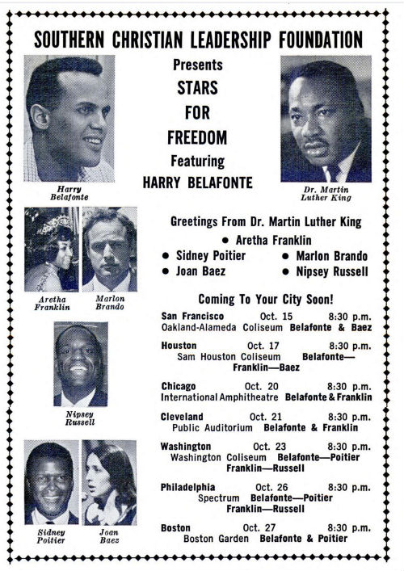

National poster for the Freedom Tour, 1967. The Philadelphia rally was held at the Spectrum. Before the rally, MLK spoke at St. Joseph’s College (now University) at the invitation of the Student Government and at Barratt Junior High at the invitation of its administrative leaders.

Speech (as presented at Stanford, April 1967) available online: https://www.youtube.com/watch?v=TRI5W95cI4A

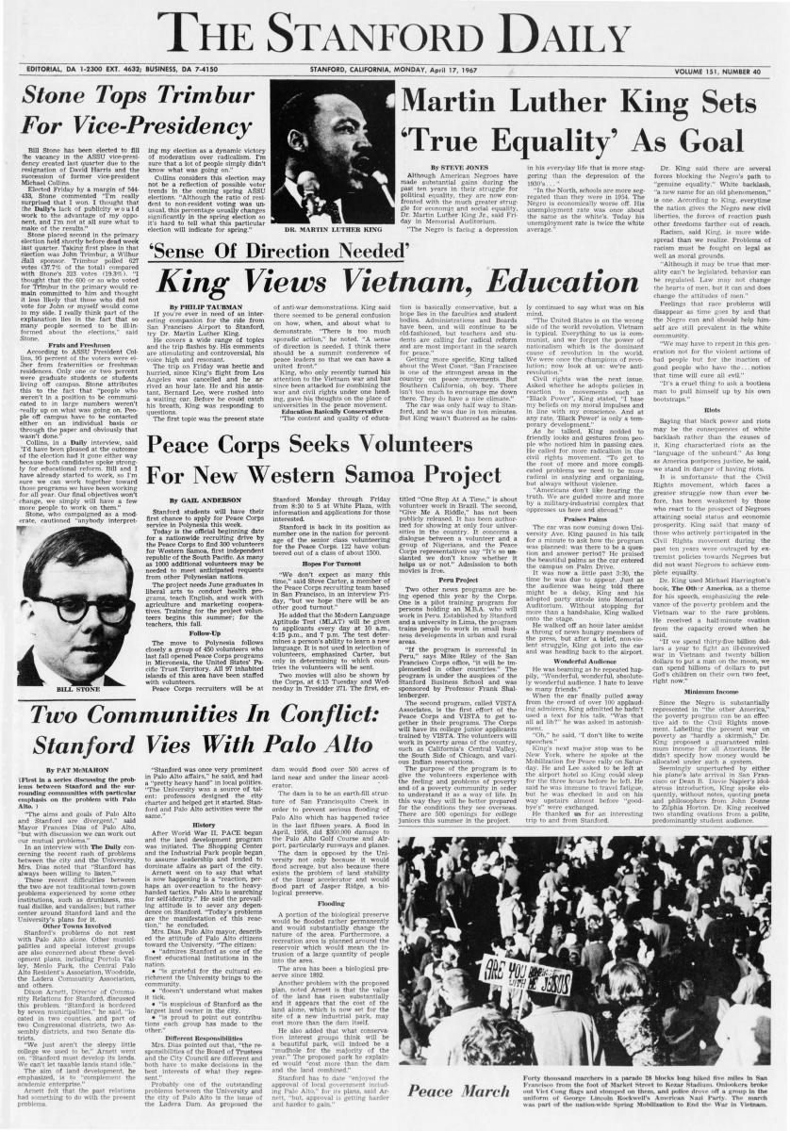

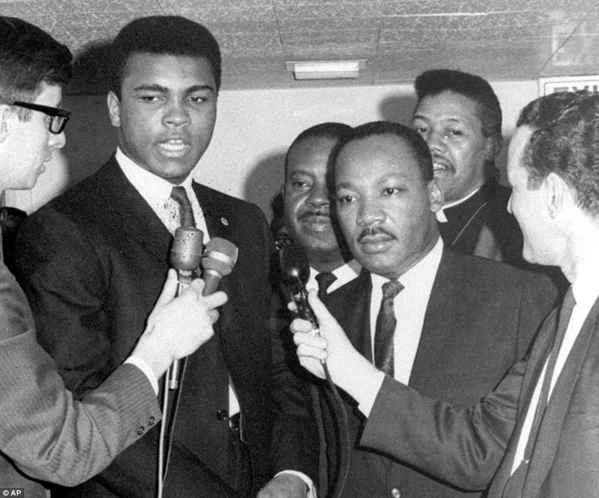
In many cities, MLK was joined by other celebrities. Here with Ali.
Girard College Civil Rights Landmark
Dedicated: 1992
County: Philadelphia
Marker Type: City
Categories: African American, Civil Rights, Education, Government & Politics, Professions & Vocations
GPS Coordinates: LNG: -75.16986, LAT: 39.97312
Location: NE corner, Corinthian and Girard Aves., Philadelphia
Marker Text: In 1930s, lawyer Raymond Pace Alexander challenged the school's restriction (mandated by Stephen Girard's 1831 will) to poor white orphans. Attorney Cecil B. Moore later went to the federal courts; by a 1968 ruling the school was opened to all races.

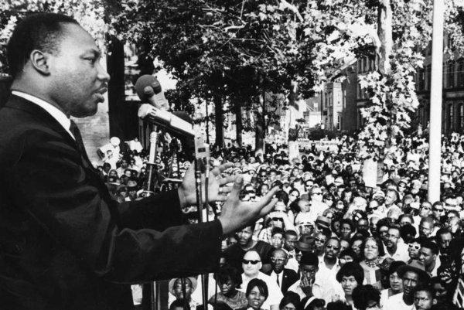
MLK addressing the crowd outside of Girard College in August 1965.

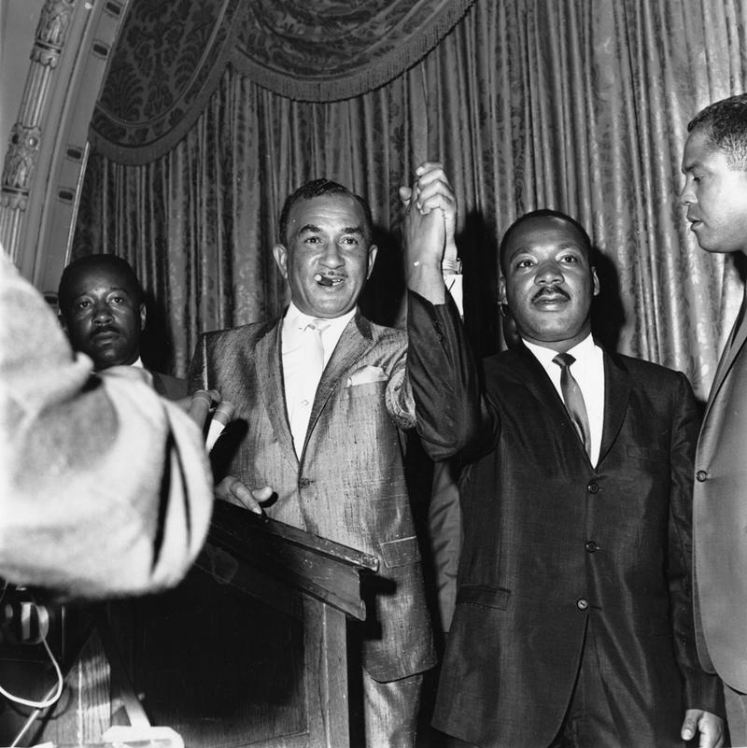

Cecil B. Moore (center) with Martin Luther King during the struggle to desegregate Girard College (1965).

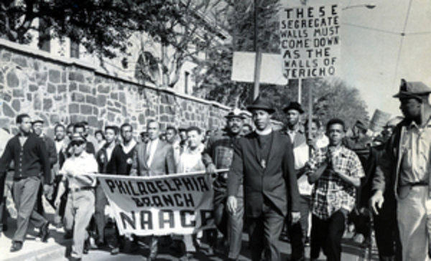
Protesters outside the walls of Girard College, 1965.

Martin Luther King, Jr.
Dedicated: Saturday, January 14, 1984
County: Delaware
Marker Type: City
Categories: African American, Civil Rights, Religion
GPS Coordinates: LNG: -75.3779, LAT: 39.8373
Location: Calvary Baptist Church, 1616 W. 2nd St. (PA 291), at Baker St., Chester
Marker Text: King lived three years in this community and ministered under the mentorship of J. Pius Barbour. He graduated from Crozer Theological Seminary, 1951. A leader of the 1963 March on Washington, King won a Nobel Peace Prize, 1964.

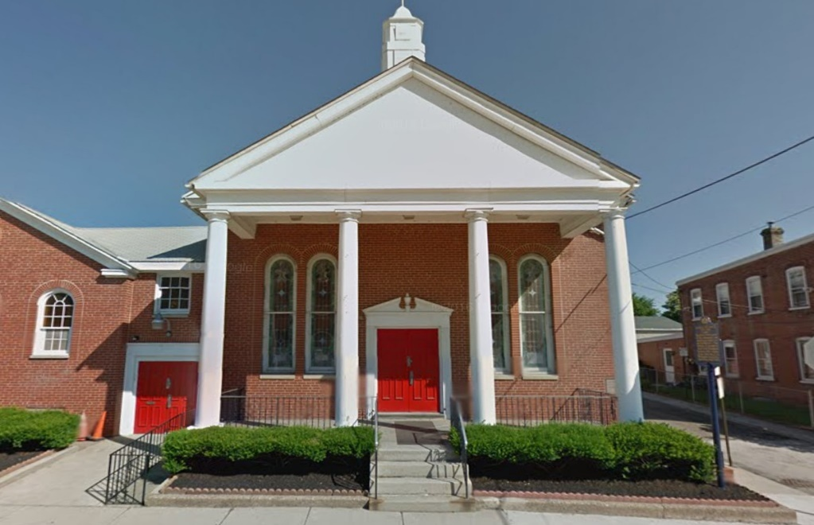
While attending seminary, MLK grew close to Reverend J. Pius Barbour, the pastor at Calvary Baptist Church. He often had meals at the reverend's house and served as a student pastor at his church. When MLK later received the Nobel Prize, he immediately returned to visit Barbour. A mirror in which he looked into and said, "Who am I?" still hangs in the church.

Martin Luther King, Jr.
Dedicated: Monday, July 27, 1992
County: Delaware
Marker Type: City
Categories: African American, Civil Rights, Religion
GPS Coordinates: LNG: -75.37086, LAT: 39.85593
Location: Crozer-Chester Medical Center, One Medical Center Blvd., behind parking lot, at Old Main, Upland
Marker Text: Minister & civil rights leader. Here at Crozer Theological Seminary, he earned his Bachelor of Divinity degree, 1951. King's three years here were a key period in shaping his philosophy of nonviolent social change. Awarded the Nobel Peace Prize, 1964.

At Crozer Seminary, MLK graduated first in his class in 1951, despite getting a “C” grade in public speaking.

Mildred Scott Olmsted (1890-1990)
Dedicated: Sunday, September 13, 2015
County: Delaware
Marker Type: Roadside
Categories: Civil Rights, Government & Politics 20th Century, Religion, Women
GPS Coordinates: LNG: -75.38773, LAT: 39.89913
Location: 41 Rose Valley Rd., Rose Valley
Marker Text: An antiwar campaigner and women’s and civil rights activist, Olmsted traveled the world on behalf of the Women’s International League for Peace and Freedom. WILPF’s advocacy was consistent with her Quaker beliefs. She headed the national WILPF organization for over 40 years and received a Lifetime Achievement Award for her efforts. She and her husband hosted leaders such as Jane Addams, Bayard Rustin and Martin Luther King in their home here.

Olmstead home in Rose Valley.

Octavius V. Catto (1839-1871) | View

Dedicated: 1992
County: Philadelphia
Marker Type: City
Categories: African American, Civil Rights, Civil War, Education, Government & Politics, Military
GPS Coordinates: LNG: -75.15593, LAT: 39.94245
Location: 812 South St., Philadelphia
Marker Text: An early graduate of the Institute for Colored Youth, Catto, who lived here, was an educator, Union army major, and political organizer. In 1871 he was assassinated by rioters while urging Blacks to vote. His death was widely mourned.

At the time of his death, Catto was living in this boarding house with eight people in the 7th Ward. The owners of the home were Thomas and Anna Bundy. The 1870 U.S. Census shows that the tenants were: William and Anna Proctor, who were most likely married and Anna could possibly have been the Bundy's daughter; Octavius, whose name was misspelled (Oadavus); Jos Green; Jessie Bailey; and John Welch. All were African American. All of the lodgers were in their twenties. It is not certain how long Catto lived in the Bundy's home. We do know that by age 21, Catto was no longer residing with his parents. City Directory in 1860 had him listed living away from his parents at 1041 Lombard Street. His father and his mother, along with three of Catto's siblings, were in New Haven, Connecticut, where William Catto was working as a Presbyterian minister. By 1867, a City Directory has Catto listed at 814 South Street.
The commercial activity on South Street is depicted in the 1930 photo below. By the late 20th Century, this section of South Street was considered a “slum” area. In 1896 DuBois arrived in the black 7th Ward amid “an atmosphere of dirt, drunkenness and crime”. The Philadelphia Tribune dubbed the ward “Hell’s Acre”. In the three decades after DuBois, social service organizations found similar or worsening conditions he had reported…residents of the 7th Ward had insufficient water supply and toilet facilities, defective sanitary equipment, overcrowding, leaky roofs, plaster and paper falling off the walls and windowless rooms. This persistence of poor housing conditions evidenced a pattern of racial segregation and exploitation. Landlords subdivided apartments and frequently whole families lived in a single room. One of the most horrific incidences in the 7th Ward was the collapse of a poorly maintained apartment building in 1936, which killed seven people (including an entire family with children) and injured dozens others. The incident became a catalyst for housing reform in Philadelphia. (see photo below) However, the “reform” resulted in practices which drove African Americans out of the 7th Ward, seeking the new public housing that was being built for them in North Philadelphia under the “racial composition rule”. This decline of black population in the 7th Ward also led to the decline of key black institutions.
Twenty-eight years after Catto’s death when DuBois conducted his study of the 7th Ward, he listed the 800 Block of South Street (even side) as having only white residences, stores and public buildings. DuBois found 9,675 residents, 54% were born in the mostly upper South, 12.17% were illiterate (compared to 44% in Catto’s time) and the average family earned the equivalent of $7,214 to $14,300 in today’s wages. At its height, the ward had close to 15,000 black residents, along with businesses and an array of social and cultural institutions.

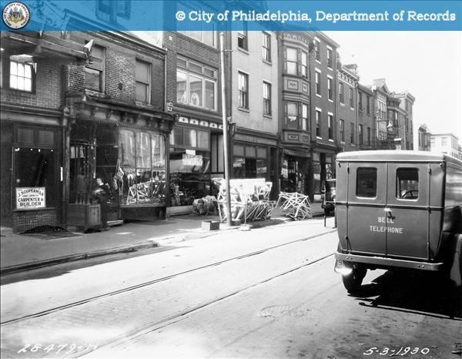
814 – 822 South Streetscape, 1930.

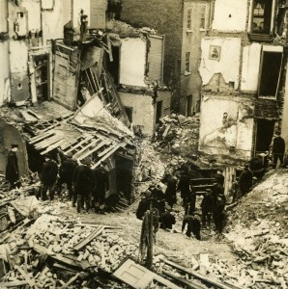 1936 building collapse in 7th Ward on South 15th Street.

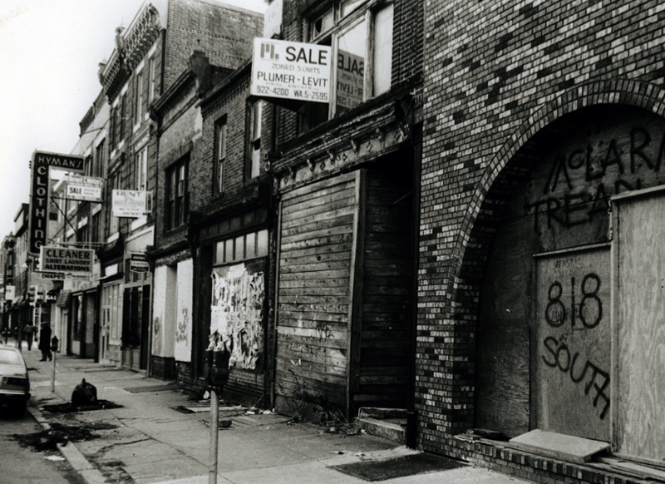
Late 20th Century view of 800 block of South Street, late 20th Century. The modest rooming house in which O.V. Catto lived from at least 1861 to his death. ((Library Company of Philadelphia.) 814 South is the 4th building from the right.

U.S. Colored Troops Grand Review
Dedicated: Saturday, May 06, 2006
County: Dauphin
Marker Type: Roadside
Categories: African American, Civil War, Military
GPS Coordinates: LNG: -76.881638, LAT: 40.265249
Location: Soldier''s Grove behind Capitol, Walnut / 7th St. across from State St. Bridge, Harrisburg
Marker Text: Excluded from a May 1865 "Grand Review of the Armies" in Wash., DC, U.S. Colored Troops from Penna. and Mass. regiments assembled here at State & Filbert Sts. on Nov. 14, 1865 for a parade honoring their courage during the Civil War. Grand Marshal T. Morris Chester led them through Harrisburg to Sen. Simon Cameron’s Front St. home to be gratefully acknowledged. Octavius Catto, William Howard Day, Gen. JB Kiddoo, & the Rev. Stephen Smith spoke.

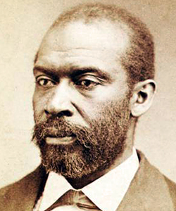
Thomas Morris Chester, Grand Marshall, was a prominent Harrisburg resident.

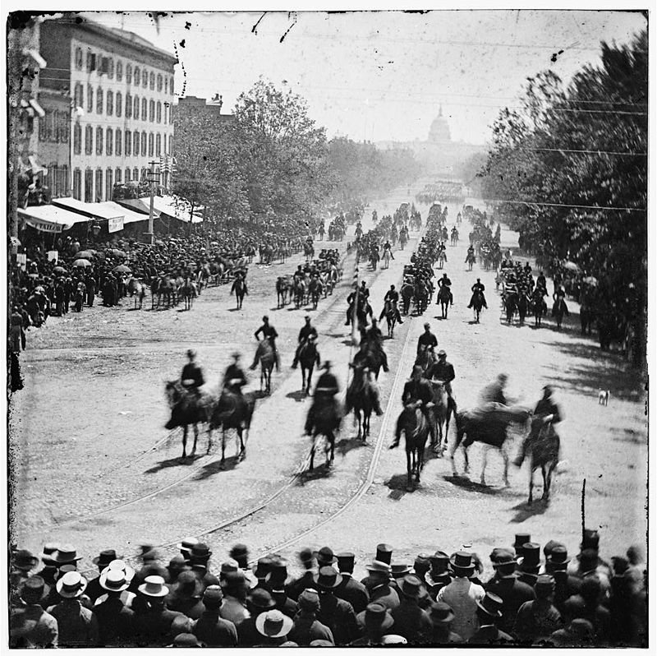
The Grand Review of the armies in Washington, D.C. down Pennsylvania Avenue after the Civil War excluded the USCTs.

Jefferson Street Ballparks
Dedicated: Saturday, September 30, 2017
County: Philadelphia
Marker Type: Roadside
Categories: African American, Baseball, Sports & Recreation
GPS Coordinates: LNG: -75.17868, LAT: 39.97844
Location: outside park on Jefferson St. at Bailey St., Philadelphia
Marker Text: The Jefferson Street Grounds and later Athletic Park hosted several monumental games here. Early civil rights activist Octavius Catto captained the Pythians against the white Olympic ball club in 1869 - the first interracial baseball game. The first National League game was also played here in 1876. In operation between 1864 and 1891, the venues saw baseball evolve from an amateur pastime into a competitive professional sport.

“A state historical marker was unveiled Saturday to tell the important story behind the Jefferson Street Ballpark at 1400 N. 26th St. in the city’s North Philadelphia area. People who use the park nowadays might not realize its significance the annuals of baseball. Between 1864 and 1891, the grounds were used by the Olympics, the oldest recognized baseball club. The team played the Pythians in the first interracial game on Sept. 3, 1869. Years later, the park was where the Philadelphia Athletics and Boston Red Caps held the first National League game on April 22, 1876.” (Philadelphia Tribune, October 2, 2017) Today the grounds are the site for Camelot Academy, a transitional school for students with special needs.

